# Q1)

Week10

Givena string, s, consisting of alphabets and digits, find the frequency of each digit in the

given string.

# Input Format

Thefirst line contains a string, num which is the given number.

# Constraints

1≤ len(num) ≤ 1000

Allthe elements ofnum are made ofEnglish alphabets and digits.

# Output Format

Printtenspace-separatedintegersinasinglelinedenotingthefrequencyofeachdigit from 0 to 9.

# Sample Input 0

a11472o5t6

# Sample Output 0

0 2 1 0 1 1 1 1 0 0

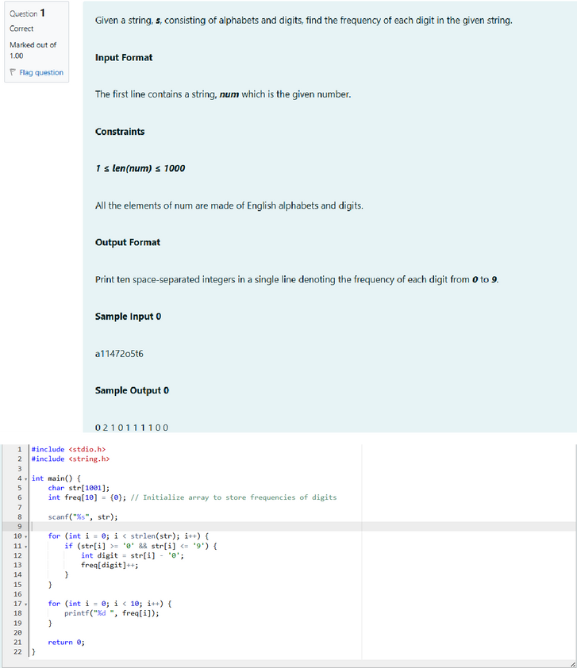

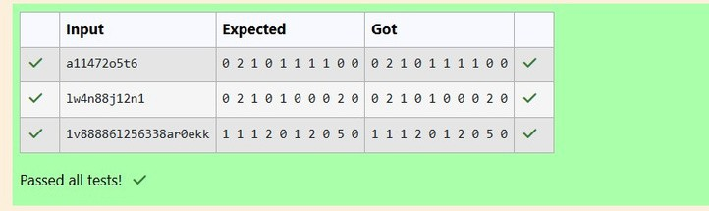

Q2)Today,Monkwentforawalkinagarden.Therearemanytreesinthegardenandeach tree has an English alphabet on it. While Monk was walking, he noticed that all trees with vowels on it are not in good state. He decided to take care of them. So, he asked you to tell him the count of such trees in the garden.

Note:The following lettersare vowels: 'A','E', 'I', 'O','U', 'a', 'e','i', 'o' and 'u'.

# Input Format:

Thefirst line consists of an integer T denoting the number of test cases.

Eachtestcaseconsistsofonlyonestring,eachcharacterofstringdenotingthealphabet (may be lowercase or uppercase) on a tree in the garden.

# Output Format:

For each test case, print the count in a new line.

# Constraints:

1 ≤ T ≤ 10

1 ≤ length of string ≤ 105

# Sample Input

2

nBBZLaosnm JHkIsnZtTL

# Sample Output

2

1

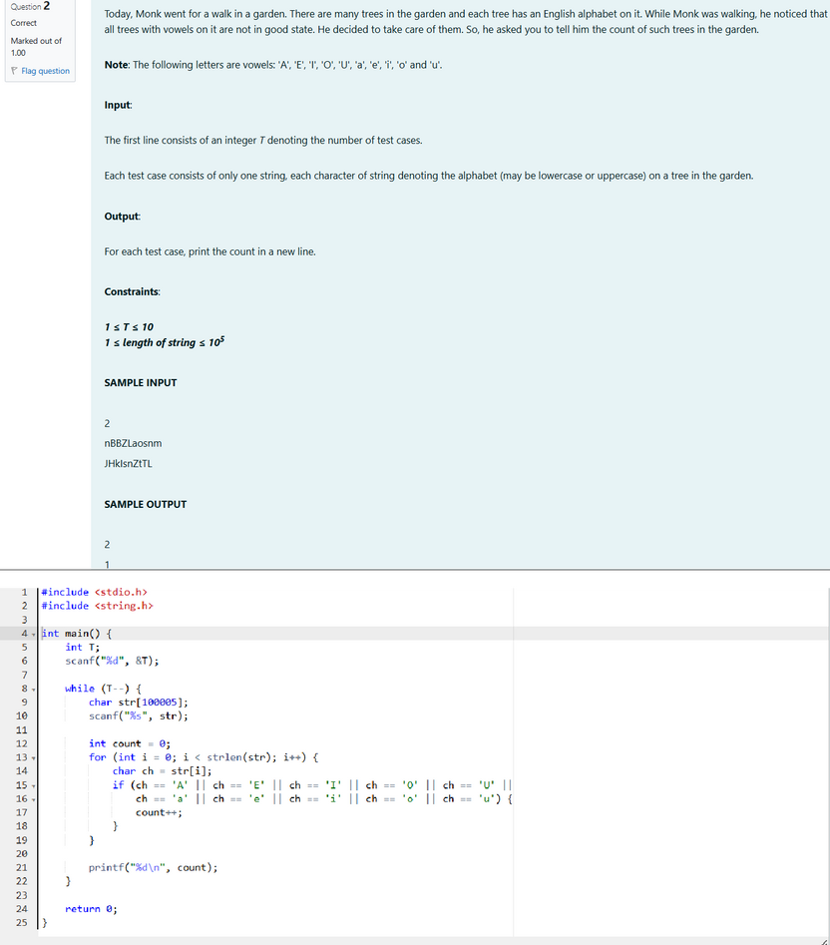

# Output:

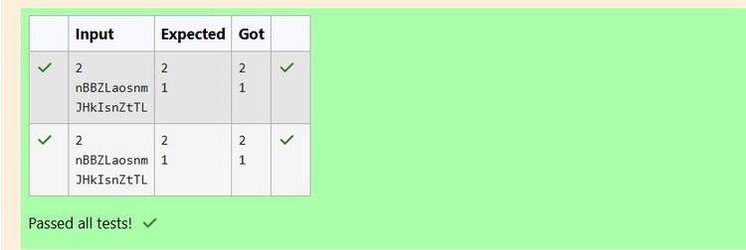

Q3)Given a sentence, s, print each wordof the sentence in a newline.

# Input Format

The first and only line contains a sentence, s.

# Constraints

1 ≤ len(s) ≤ 1000

# Output Format

Printeach word of the sentence in a new line.

# Sample Input

This is C

# Sample Output

This is

C

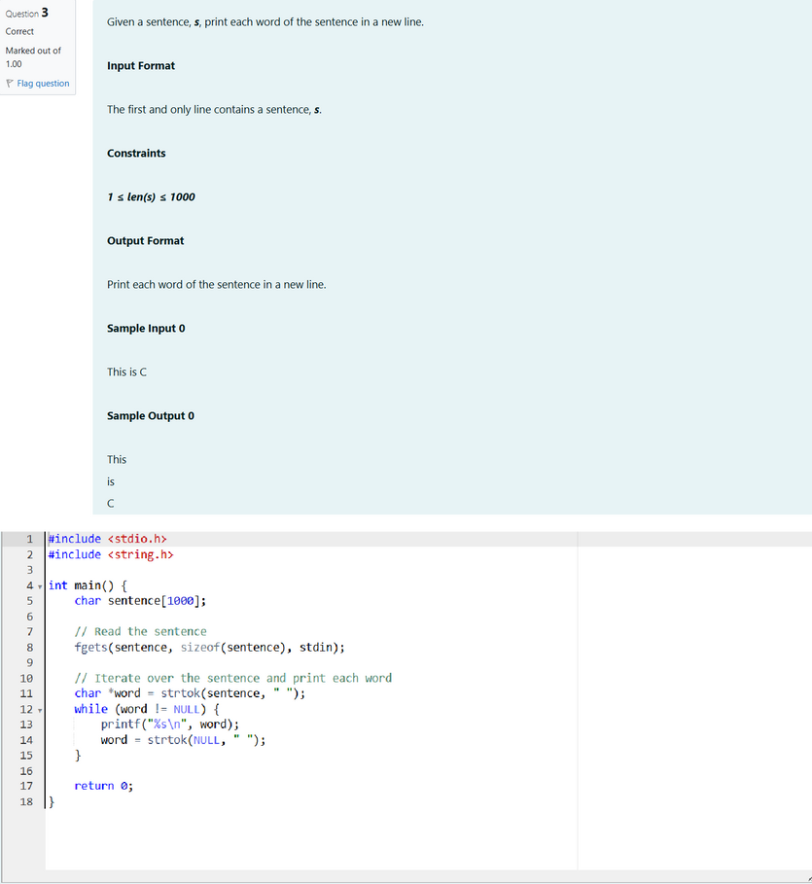

# Output:

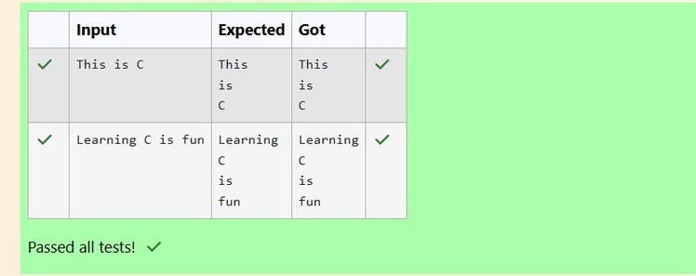

Q4) Input Format

Youaregiventwostrings,aandb,separatedbyanewline.Eachstringwillconsistof lower-case Latin characters ('a'-'z').

# Output Format

Inthefirstlineprinttwospace-separatedintegers,representingthelengthofaandb respectively.

In the second line print the string produced by concatenating a and b (a + b).

Inthethirdlineprinttwostringsseparatedbyaspace,a'andb'.a'andb'arethesameas a and b, respectively, except that their first characters are swapped.

# Sample Input

abcd ef

# Sample Output

4 2

abcdef ebcd af

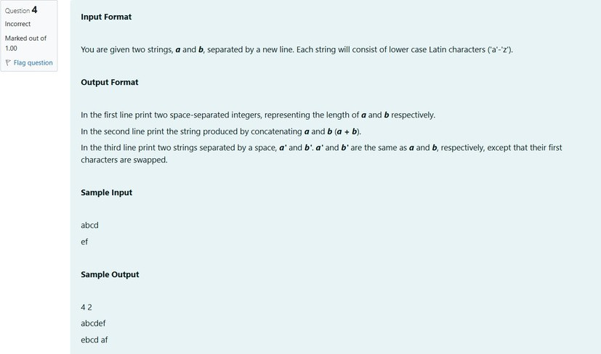

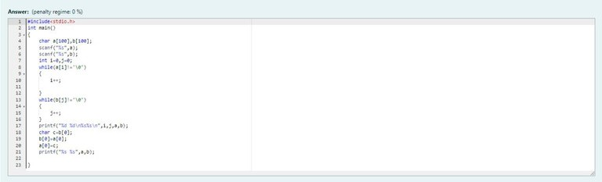

Output:

